**Design**

1. Concepts

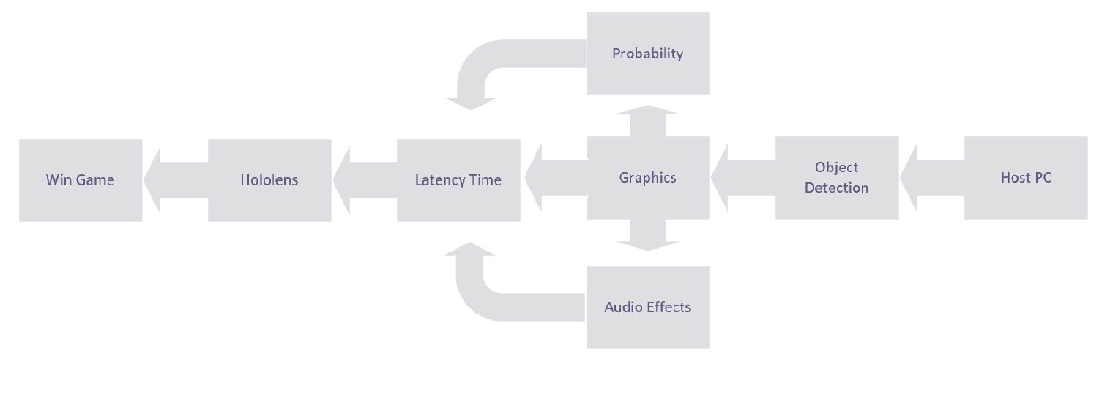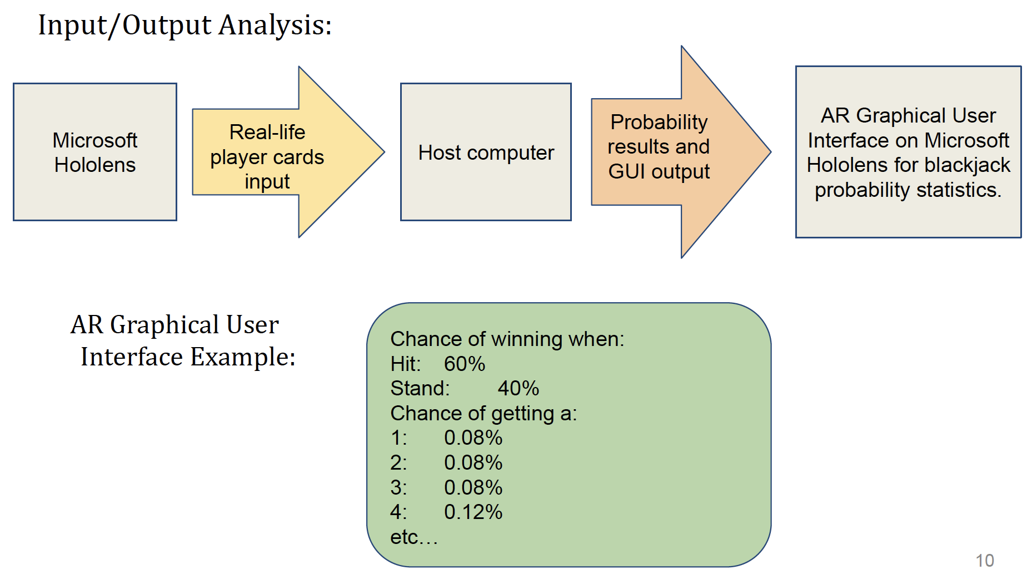

1. Prototyping/Breadboarding
   1. AR Remote Rendering Black Jack Application
2. UX
   1. Visual Overlay/Effects
   2. Audio Effects
3. Use cases
   1. Health Sector
      1. Surgeons
      2. Radiology Scans
   2. Construction
      1. Photogrammetry
   3. CAD/PLM integration
4. Hardware
   1. HoloLens 1
5. Software
   1. Unity
   2. C# AR Black Jack Application